26 February 2010
Not a vast amount waves the Union Jack for me these days, but Nigel Farrage did. Pity though he felt compelled to restrain himself in the name of good old British tact. I’ve got nothing against the EU President personally, just I find the idea of a man there to represent 500 million people obnoxious when you consider that nobody voted for him, and I sincerely hope none of you would try to defend his undemocratic appointment to the position. Maybe the UN observers were all tied up inspecting the mechanics of democracy elsewhere, and they had to go ahead without. I find it quite worrying.

Judo? Well, I think I need to get in shape a bit, so I’ve looked into training routines and there are a lot of things. But I also looked into vegan nutrition for sport and found that they all seemed, and I say seemed, to have shares in the same energy bar companies. They recommend natural fodder in the text, but when you hit the eating plans it all seems to be protein drinks and nutri bars. Makes no sense to me, protein drinks are incompatible with the human organism and sooner or later cause problems in other areas. Nutri bars are generally packed with unnatural proteins, and those that aren’t cost too much to base a diet round. However I did conclude that there are plenty of helpful things I can get and eat, like porridge, which I am about to go and cook now. No sugar, no honey (which I don’t eat), no rice syrup (which I can’t get in Kaz)... just boiled mushy oats.

Then I have my lesson plan to write for tomorrow. I am being observed, which I don’t like. It means I have to shut up occasionally. They say the best teachers talk the least. I wonder at this, maybe the same best teachers don’t like being the best teachers and wish they were the best at something else. I like my job, it excites me, and therefore I have lots to say. How anybody can sit in silence when you have such wonderful and interesting people around you I know not. It’s like being given a dartboard and arguing that the best players don’t throw too many darts at it.

The theory does check out, naturally, if the teacher dominates the space then the students don’t get chance to do, or talk, or even think. I accept I should talk less but I also encourage people not to take these pretentious TEFL theories at face value. It has, yes, been proven that limiting teacher talking time can be beneficial but unless I am hideously misled, it has never been proven that you absolutely have to cut it out, I mean, that there’s no other way.

In any case, my boss won’t be able to watch because she’s too busy dancing these days after having found a host of dance schools in the area. So I will indulge in what I call ECC, extensive chit chat.

Blattering? Or am I too humble?

25 February 2010
It’s a human trait to put things off, to delay, even things which would benefit us. It might not seem right. Contestable though it may be, measurable evidence would point to us only living once and the passage of time reminds us not to waste this. Procrastination, an unfortunate habit of mine, is the thief of time, above any law and beyond the reach of human justice... once time has passed, we can enjoy our memories of it, forget, or regret. But there is also a theory that we turn our eyes because the time is just not right.

I have to believe this. It took me a month in my new flat to notice a nail on a disused door stored on my balcony. I have to believe. How else could I forgive myself for failing to realise that the perfect place for a dartboard was right here under my very eyes? No, I have to believe. All will be revealed at the right time, in the right way and in the right sequence for me, that’s what metaphysical healers would have us know. And now, having needlessly missed four weeks of darts, the only antidote to the bitterness left by the reality pill is the tree hugging so-called comfort that, somehow, in some perverse way, I was ‘not supposed’ to be chucking tungsten arrows this last month.

Not supposed to play darts? I quiver to think why not.

I’m a lamp short of full functionality but the new board is sitting very pretty, a few trial throws in the near dark have reassured me that still having the same waistline nearing 40 as I had at school have not rendered me ‘dartslexic’ (like dyslexic but with dartboards), as I landed a few close to the 60 and left no holes in the makeshift surround (its erstwhile box). I look forward to landing a few ton-80s and taking pictures of them for the blogge. Watch this space.

Other progress made since I realised I am no longer 18 and more likely to pee my trousers than wet the bed has been joining the judo club, going back in spite of barely being able to move (damn stiffness) and toying seriously with the idea of taking dance lessons. It’ll have to be decent music, I hate R and B, hip hop, Reggie Hammond pipe organ music and morris dance music but Ibiza style dance mix stuff has the right energy. I’ve tried dancing to Anti Santa this week but it’s more philosophical than groovy, not a bad thing but it leaves me still in search of a suitable beat.

Speaking of beat, the Kazakh bobbies stopped me last night. They weren’t looking for me but I could hardly avoid them. They were asking about a block of flats on my street, none of which are numbered. When they heard me speak Kazakh they asked me where I was from. I simultaneously replied that I was English and reached for my passport which I thought was quite inevitably the answer to the next question. Nope. You see, so few non-Kazakhs speak Kazakh (if any) that the kudos not only doubles but trebles if you can. Not only was passport checking no longer required, but neither were formalities of any kind as I became guest of honour and VIP for a few minutes. The fact that I had gone on a shoplifting spree earlier on in Ramstore was no longer a concern and they left me nursing my stash of loot with warm smiles and firm handshakes. Five minutes later they drove past me and slowed down to wave.

Disclaimer, those not equipped with the immediate ability to deduce when my subtle brand of irony kicks in and I am therefore talking total cr*p should consider themselves hereby informed that ‘I didn’t nick nuffink from Ramstore’ and ‘I ain’t saying nowt wivvout me lawyer!’

I’ve been a lot more energetic recently, and motivated. In traditional Chinese medicine the functions of stomach and spleen (terminology which also refers to far more than the physicality of the ‘organ’ described by modern medicine) are transforming and transporting. This is a constituent part of the whole human process of taking in, refining to the level of body mind spirit, and eliminating. The very refinement of that which we take in is not possible unless it can be ‘changed’ to become compatible with the person themself, be this on a physical, mental or spiritual level. (This explains why MacDonald’s etc makes us fat. It is incompatible with the human organism and it cannot be accommodated (nor eliminated) by the system, so is put aside in adipose tissue until such time the body can deal with it. Sad thing is, people don’t allow their bodies to get to the job.)

We don’t only take in on a physical level but on a mental and emotional level too. Albeit at a higher vibrational density the body mind spirit has to process this and either assimilate it or excrete it, in the healthy mind thoughts that serve us ‘become us’ and govern our wiser actions, those that don’t are let go, rather than allowed to govern our destructive actions.

The stomach spleen function is to refine that which we take in and get it moving. A breakdown in the base requirement to do this has consequences ranging from the physical (lethargy, obesity, dampness), and the mental (depression, low motivation, inability to move on) to the spiritual (believing yourself to be something you no longer are, for example).

Simply laying off meals after 6pm has given my stomach and spleen the space they need to regenerate the vitailty I have needed to get moving, to lose the mental obesity and get my ideas put into action. It won’t transform me overnight, but it’s already been a big step.

Leaving myself out of the following equation, consider, mental illness is borne of the same imbalanced processes as physical illness. In traditional Chinese medicine (which, come on now, would simply not exist today if it were ineffective) each of the ‘organs’ has physical, mental and spiritual functions. It doesn’t mean you will always experience imbalance across all three spheres, but very often, yes. People are quick to accept that the heart plays a role in the process of love (if love is a ‘process’) but many tend to laugh at the suggestion that the liver is connected with anger. It’s bad news, some of the thousands of ‘nutcases’ clogging up institutions up and down Britain are befuddled by a combination of simple things that their bodies are not equipped to deal with (including prescription drugs) but they are only experiencing the same malfunctionality as people with physical ailments, on a different level.

Add to that the swathes of people living profoundly unfulfilled lives spiritually and it makes you wonder (well it makes me wonder)... where exactly did we go wrong?

I have a day off tomorrow, unscheduled. Darts day! A new national holiday. May I be the first to thank my students for either finishing their course or going away for a week. Let them be back for skiing on Sunday.

But come on, how could I miss that nail?

22 February 2010
I can’t say I feel very creative today, although I do have some things to say. I’ll just put them in a list and get back to my slumbers, see point 2 for an explanation.

1 – Went to judo on Saturday, it was nice to be back on the mat, and in blue, but I spent more time down on the mat, having lost a little slickness, and then noted that my body needed a scrub and a half to get rid of the blue colouring it inherited from my new gi.
2 – Today I am very stiff and can hardly move, especially after lying still for a few minutes.
3 – Skiing was fun today but difficult, my body was tired which is not conducive to good skiing and the overnight snow had left a very thick covering on the slopes and it was too deep to ski well on. When it got pressed down a bit by skiers et al the piste was covered in mounds which were difficult to interpret. 60% of people there just fell over consistently.
4 – I have actually studied a few times this week. The S word!

5 – I have a new look. My clippers broke somehow and instead of replace them immediately I went to a cheapy hairdressers for a grade one, which turned out to cost about $1, considering good clippers would cost about $100 here I think it’s probably not worth it, I will trek down every week for the closest trim which I would say comes in at about 0.4 mm, as opposed to the 0.8mm of previous. I have already been mistaken for Telly Savalas several times.
6 – My PC is behaving strangely.
7 – But then so am I most of the time.

Have a nice day.

17 February 2010
I can’t really explain why, but I winked at a student yesterday. It was inadvertent and not remotely inappropriate, but in taking advantage of the slip I chose to teach her the word and then slipped into teacher talking mode, a lengthy spell of droning which culminated in a declaration that I am ‘not usually a winker’.

Well that’s very reassuring, isn’t it?

Another student, one such obsessed with his phone, demonstrated to me a handy function which was curious, in it’s own way, handheld sat nav. I checked it out in the local store, all I could find was satire nav, apparently it has Sandy Toksvig telling me the way interspersed with off the cuff remarks about not enough being spent on road signs chuckle chuckle. It’d be worth it to hear her wit, the woman who single handedly renders my chauvinistic grip on a gritty belief that men make better comedians a mere irrelevance would make a fine voiceover for anyone stuck half way down the high street on a busy Friday. If you can keep up with her.

I wouldn’t say I was sexist, but music and comedy are generally better created by men. Sorry, but if you offer an opinion to the contrary I can agree to laugh at that so I suppose I’ll be proving myself wrong.

This morning was marked by a long overdue jaunt over to the judo club which luckily does have judoka over the age of 12, although not too many. It has been my ambition for long enough now to get my black belt, and now there’s no reason why I shouldn’t. Other good thing is it doesn’t seem the club will try to translate anything for me, the instructors spoke to me today in Kazakh, I said I could speak Russian which is a rare admission for me but in reality I had already told them.

But the cool thing is that in 15 years of judo I’ve always had a white suit (we call judo clothes ‘suits’, which is wrong in that they should be called by their Japanese name of ‘gi’) but out shopping for one on Sunday I came across a very nice one in deepest blue. In some dojos, certainly in England, the colour is white and I think this is a rule in most places, but here either colour is OK. So I opted for the change. I didn’t buy it in the shop though, theirs was toooo big. I got one from the club. Not cheap, but worth it if I can do contests and gradings again. I would prefer to opt out of Nage No Kata if possible, indeed putting the very ‘no’ into it, but it’s usually part of the higher grade landscape.

Here

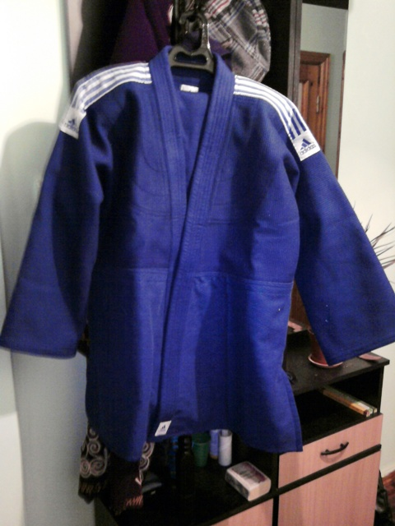

The thing about my judo, having also started very young and done it for so long, is that most of the moves are almost second nature. Luckily so as I don’t have a good judo brain and my technique is poor. I get by in contests by fighting instinctively. I used to get warned for passivity a lot, which technically is when you wait for an attack instead of initiating one. A bout between two judoka with this approach can be excrutiatingly boring. When people attack me I counter.

If you look closely at this picture, taken near the main town bazaar, you will see hundreds of little dimples on the road surface. Ice. I wonder how the ice makes its mind up which area will be broken down and which will resist and retain its original height. Is it some kind of reward for good work, or a punishment for something? I think we should be told.

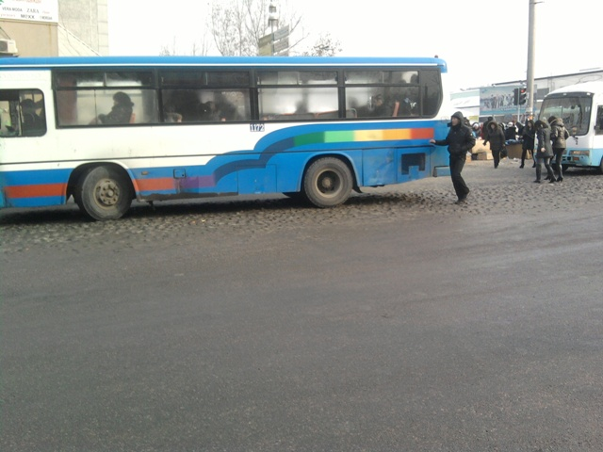

Another thing we should be told is why the price of sterling has fallen so much. Is this all they’ll pay for it, 23 tenge to the pound? It was 245 last time I looked.

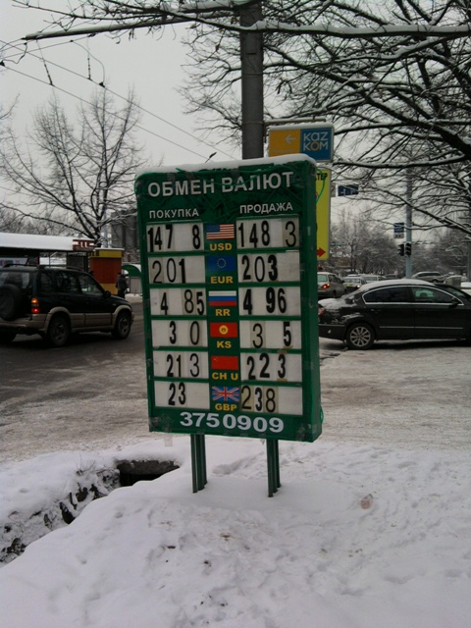

12 February 2010
I’m mildly taken by the thought of inventing a new word which makes it into the dictionary. Right now, if the Oxford English got in touch and asked me to submit one for consideration it’d have to be one my sister invented about 25 years back, mib, which is the action of a cat, usually kitten, when it pats its ‘prey’ with claws retracted. It’s something that usually happens during play and naturally opens the door for a host of other words like ‘mibsome’ which would describe a cat given to mibbing with some regularity, ‘mibbist’, which would be a cat fully in favour of the act, and ‘mibe’, which is what you pay a cat not to do it while you’re watching the Six O’Clock News.

However I did come across a potential new word today which would cater for the gap in the market sorely felt by people who want a succinct way of describing

talking utter boll*cks under the misapprehension that your salary and fancy job title gives you some kind of moral and intellectual superiority over other people. To assume that people agree with you because you don’t know the difference between bigoted and privileged opinion, and that of the millions of people who do actually know the price of a loaf of bread.

So what is the word?

To blatter.

I’d hardly say this at the turnstiles of any club, but from my comfortable distance I’m not averse to a momentary blattering of my own. So, right now, frankly, I don’t care if football clubs in England go bust. Maybe I care, but I think it just has to happen. Money is rotting the game, very few clubs are operating without debts blindly accrued when it seemed the sport had available a bottomless pit of wonga. The greatest empires in history have oh so often fallen because they assumed they were untouchable, life has a way of kicking backsides when they become the focal point of the anatomy... the number of complete arses running football these days have to lose the it-won’t-happen-to-me mentality for the game to survive. The only way for this to happen is for somebody to go lower end up, let it be a club that deserves it.

I won’t mention any names.

It has been cold here this week, very cold, maybe minus 20 and colder by night. I love it when my clothes freeze on the line, but that’s not my point, and in any case it makes me sound peculiar. I came home from work today and some bloke was simultaneously hot-wiring and trying to explode a car. I understand there is method in the apparent madness, but the tendency to waft open flames under the engine can make one feel a tad nervous. Would never happen in Egypt.

Every time I see you, I can’t believe my eyes
I trace your body shape from your throat down to your thighs
Then I pray to God that one day I’ll watch you fry
Because I’m partial to the occasional portion of home made chips

Visit here for the real and vastly superior version. Cool song, take it in good spirit now.

11 February 2010
I may have imagined it, but I’m sure I saw an ad for a new film, The Portrait of Dorian Gray. It further proves they’ve run out of ideas but this aside, this has to be a great film. I saw the original and liked it, but I think it was too wooden to make a great film, not enough real human emotion. We’ll have learned from that, the new one will surely be worth seeing. Unless I dreamed it.

I have opened a new page on the site dedicated to Stourbridge, a medium-sized English town in the Black Country which if I get my act together will actually even have some content. Stourbridge is a cool town, very young and vibrant, without being a hub of social activity. I moved there in early 1997 and stayed for four years. Best place in the UK.

Stourbridge marked the beginning of my rabid insistence on only speaking the local language when I live somewhere, and I often amused locals with my feeble command of their quaint vernacular. For those of you who don’t know, the English Black Country (so called because of the colour of the erstwhile industrial sky) is famous for its accent and to a lesser extent its dialect, very difficult to imitate and even more so in writing. You could try this youtube link to get an idea, have a laugh,

here, it's the guy on the right to listen to

but will otherwise have to take my word for it. But Black Country folk do it their way. No, they don’t need English grammar, the ever dependable verb ‘to be’, scourge of the English language classroom in countries as diverse as Russia and Egypt takes on a fresh new form when round Dudley way. Consider these structures, perfectly acceptable alternative forms of English (if my students produce them in class I decline to correct them and instead give them free tickets to Dudley Zoo) which I intend to use more in daily conversation:

I am
You am
He is
She is
It is
We am
They am

Short forms similarly, you’m, we’m and they’m, perfectly correct.

Take the present continuous
We am playing tennis
This is the closest approximation to Chaucerian English still evident in modern times and if you’m not using these forms you’m letting the side down.
I struggled to master it, my usual language acquisition ability notwithstanding, because I kept saying ‘he’m’ too. Nooooo goooood!

People from the Black Country are often referred to as ‘yam yams’, not because of a penchant for sweet potato but for their tendency to contract ‘you am’ to ‘y’am’. Again, this is perfectly correct English and the decision of Oxford University Press et al to leave it out of their coursebooks can only be considered downright elitism. Thatcher’s children!

I for one look forward to my next Elementary course so I can get them properly trained from the start. When the modern ‘posh’ forms become fossilised (such as ‘we are’!!!), it can be very hard to unteach them.

Am you listening to me?

Tomorrow should be a more relaxing day because my Upper-Intermediate students am doing their final test and the one-to-one student’s lesson is already planned. But then I have Italian. The problem teaching Italian, apart from absence of flexibility in the verb ‘to be’ is that often you can’t be sure if the piadina is made with lard. There is a place in Fano which offers a vegetarian one, but in Emilia Romagna, traditionally, it’s crammed with grime.

By far the thing in life that annoys me the most is being asked endless questions about my diet. I bear people no ill-feeling if they do ask because I don’t expect most people have come across it before, but 20 years of being expected to explain it all reduces your enthusiasm and you tend to similarly shrink the conversation to a more manageable size. This usually means ‘zero’. However as some of you have seen your own perfectly reasonable interest in me thrown back in your faces over the years, I will now endeavour to explain precisely why I eat as I do.

Or maybe not. Like I say, it’s boring, ask me about cirrus clouds in Costa Rica instead. You’ll get more of a conversation.

I knew I guy in the South of Italy once, who I have to say is one of the nicest people on the planet, who claimed only to have eaten fruit for years. I think this is what he meant, at the time my Italian was OK but I was new there and did as I do now in Kazakh, nod and say mm a lot, partly because I don’t want to be seen to not understand, but also because people don’t improve their language skills by stopping and starting all the time. It’s better to understand a complete discourse 70% than a few short sentences 100%, unless it’s a transactional situation comprising just those few short sentences. Fruit, however, is disgusting. It’s like dogs, nobody likes fruit, people just pretend to because society expects! Wuff, giz an apple!

I went to wire some money home today with Western Onion, but then I remembered that I don’t have spare money, I’m a teacher. But if this seems like a negative affirmation, consider, JK Rowling was a TEFL teacher once, worked for the British Council and barely had a pot to go for a slash in. Many clairvoyants over the years have spoken spontaneously of a plethora of words in me and one went so far as to say she felt a trilogy spill out of me during her hands-waving-hippy-mantra thing (which I believe in, I add). Problem is, I can feel it too but I don’t know what to write about. The closest I’ve had to an idea yet was a play about a knight in shining armour who goes abroad to fight for King and country, and gets lost on the way in Europe without any dosh. The lad had to teach English to pay his way back to England and did so only to find that it was a dump but he’d never noticed before, had he, Mrs?

You know, a real Sir Lancelot meets Mrs Miggins sort of thing, full of Shakesperian third person endings and Black Country second person endings. To am or not to am, considerably poorer than yo, etc. I wrote three pages and then term started. Show me a writer who is also a full-time teacher and I’ll show you somebody who doesn’t plan lessons nor probably go to them. Classrooms drain your creative charms, ask Stephen King, most prolific writer whose books I want not to read, barely wrote anything while working as a teacher.

And this guy...

Were it not for classroom duties and demanding students, he’d be a viable alternative to Bob Dylan.

5 February 2010
I won’t delve too deeply into the realms of karma or the pre-ordained, but there’s something about being a teacher that makes you consider if it’s what you came here for. Some people live better lives, others worse and I won’t turn it into a competition of any kind, but when you see or hear of people raking in fortunes, and reflect on the fact that 95% of those working in classrooms worldwide are shockingly exploited, it makes you wonder why there is any such thing as a teacher.

I came to the conclusion recently that teaching is a form of ‘give’, of service. Many people live lives in which they predominantly ‘take’. I’m not being judgemental, they may well work hard for it and share their rewards unselfishly, but all considered, they are net gainers. Teachers are net contributors, and more than aware of the fact.

So what makes a teacher, who has a choice, become or remain a teacher?

Call it what you will, inner commitment, karmic cohesion, diligence, devotion to duty and those we serve... there have to be givers and takers, imagine a world where we all just took. Think of the types who will work 14 hour days for barely more than their rent, the types who will, when not having been paid for months, drive down a frozen river to the next town to attend a conference on teaching methodology... there’s something inside every true teacher that they may not want to be there, that maybe they try not to yield to, but which ultimately won’t let them leave the classroom until they have fulfilled their oath of service.

Pity those teaching in English comprehensives. It must be very frustrating to know that your life’s purpose is to serve a bunch of yobs.

Speaking of yobs, something you don’t see in Kazakhstan is groups of threatening or disgruntled looking teenagers. Teenagers here can be spoilt but in contrast to some of the examples walking round Stoke of a Friday evening they are divinely unspoilt, emphatic stress on the ‘un’. There are none in these pictures, because they were all behaving themselves in other locations at the time I took them.

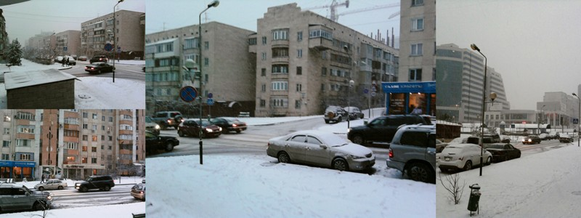

I modified them using the excellent Picasa Photo Editor software I have, but I had to laugh at one thing... there is a function, which I used, called ‘warmify’. I made a collage and then warmified my photos. I suppose it’s better than ‘simmer’, when I take photos of trees the program will expect them to be the same each side.

Boom boom!

2 February 2010
Note to students of English, if you can understand today’s blogge, don’t waste any more money studying English. You don’t need a teacher.

Yesterday was a funny kind of day. I worked 12 hours without a break so I got home tired and fed up and hit the bottle. Luckily it was just a hot water bottle so I didn’t bruise my knuckles but instead ended up them stinking of rubber. Later on, not rid of the pong nor feelings of pent up frustration I decided to go out clubbing, but it turned out I couldn’t find any seals, not even of approval, thus plodded on home bored, frustrated, fed up and now not bathed in glory either. To deal with the growing indignity I turned to Gideon’s recipe book and found a cunning strategy for dealing with isolation which involved peeling carrots and reciting some ancient verses, forwards. It didn’t work, the magic potion turned out to be a damp squib which admittedly came in handy for wiping the peeler, but did nothing to raise my spirits.

For those of you still wondering if said ‘hitting the bottle’ made some sort of pseudo-euphemistic suggestion of hitting the bottle, it did not therefore I will not pursue the chain of loose metaphors any further and extend the contribution of the phrase ‘raise my spirits’. I only drink water.

Sunday was fun, finally, after three weeks of wondering if we’d make it back to the snowy slopes before they became grassy slopes did we reach the white crested undulation that is Chimbulak, quite a relief both in the geographical sense and the joyful sigh sense, a few weeks off and the law of Murphy threatens to adopt its (very slightly) ruder moniker and consign my new skis to the eight month pending pile. But the seasonal heat wave did not melt the snow ahead of the long awaited return to action, and we got five or six hours of mountain sliding in before hunger kicked in and we sidled off down the road to Almaty (gingerly).

A colleague who I will not name has received a keen offer from a local company which seems to need English teachers. From what I can gather, it would involve an almost triple pay rise. I would like to be offered this job myself, so I can say no. It’d probably be better hours, perks, salary and chance to ingratiate oneself with influential people here and there, but Murphy it, who needs more money (apart from me)? I like my job now cos I can do what I like (luckily what I like tends to coincide with what my students like therefore what the employer knows is good for business), yes, what I like. I have no pretentious boss asking for my lesson plans at random so they can see if I am doing enough drilling. I have nobody checking to see I arrive at school in time (maybe because I’m usually there four hours early) and more importantly, I don’t get asked to use the books task for task. Maybe in a new place I’d have the same freedom, but I suspect this place'd be more hands-on.

Speaking of Murphys, the Fulham captain wrote one of the best grammar references available. Strange, I met him when he played for Crewe, back in those days he thought grammar was his dad’s mum, how the Premiership must encourage intellectual processing these days.

Hey, maybe they could try it out on John Terry.

You might be familiar with Robin Williams’ quote about men’s brains, blood supply and othersuch body parts... the beautiful game does seem to prove this theory correct. Consider, Wayne Bridge, when spoonerised, becomes Brain Widge. I understand this was one they did try out on John Terry, and the two have not spoken since. Something to do with blood supply, thicker than water maybe, but not as thick as your average professional footballer.

We can only be glad their wives are usually worse. Over here, on me ‘ead! Such scintillating conversation.

1 February 2010
Proud to be (a bit) Egyptian. Again.-Me

So Egypt win again. Football is beginning to take notice, I wonder if I have something to do with this. I could try not to be so vain, but the coincidences are stacking up to quite the extent that I have decided to rekindle and republish a blogge from May last year. Not my usual style, but then, like I say, another of my teams has come out on top.

Over the years I have however supported or had a soft spot for a number of teams. Although it pains me to say it, from age about 7 to 16 I thought I supported Liverpool. I now realise it was an illusion, something connected with bed wetting and craving for raw cauliflower. In any case, they won the league most years during that period so I was able to enjoy my football then. Divorcing them in 1991 left me free to start a more meaningful relationship with my local team, Crewe Alexandra, which essentially never ended but to which commitment waned massively around 2003. During that original period they went from the old Fourth Division to the Championship, a remarkable success story which brought a lot of pride to a small town. The fluctuating decrease in my involvement and interest strangely parallels the decline in the club’s fortunes, as they once again find themselves in the basement division.

Around 2000 I discovered Italy and needed a side. I chose Roma, mainly because of the colour of the shirt but in spite of this rather arbitrary reason it was a choice that I very quickly justified emotionally, watching them fight for a second successive championship under the now England coach Fabio Capello, with a young Francesco Totti still at his dazzling best was gripping stuff, and although they lost out to Juventus on the last day of the season, it was another year of footballing success.

I have also enjoyed successes during minor flirtations with teams who have themselves strangely ceased to play so well as I have moved on. I watched Puglia side Fidelis Andria make the playoffs back in 2004 and then go up to Serie C1. That season I never saw them lose and perhaps only even draw the once. I moved on to Crotone and learned that Andria had gone bust, as I sat watching Crotone get into Serie B and almost Serie A. Once again, I left town and they too were relegated. Then a year in Verona supporting Chievo during the season in which they made the top four. After I moved away from there they failed to get into the final stages of the Champions League, and then got relegated. Luckily, it was just a blip.

Add to this a World Cup victory, two African Champions Cup wins and a victory in the African domestic league and you can see why my sustained interest in the game has been so worthwhile. I’m not saying I’m any kind of lucky charm for these teams but it’s an ironic correlation. I watch, they win. I just hope it gets noted at Lo Stadio Olimpico and they offer me a free season ticket.

Or maybe not. In this case at least, Egypt don't need me. They are simply the best in Africa. Ever!

